FOR IMMEDIATE RELEASE
Contact: Cargile Williams
elizabethcargilewilliams@gmail.com
423-202-8431


Courses Restaurant at Watauga Brewing Introduces New Kitchen Team, Tuscan Menu

JOHNSON CITY, Tenn.—Courses Restaurant, on the second floor of Watauga Brewing Company, has announced a new kitchen team and newly developed Tuscan cuisine menu. The fine dining restaurant features rotating menus from different regions worldwide, with a focus on European cuisine and world flavors.
Executive Chef Zach Anderson and Chef de Cuisine Ian Mitchell have drawn on their experience in other fine dining establishments and with local food production to create a menu that highlights fresh ingredients such as Mr. Stripey tomatoes and South Carolina peaches.
“Our aim is to create and support sustainable food systems, from seed to sprout to table,” Anderson said. “We’ve carefully researched and developed the current offerings to reflect the hallmarks of Tuscan cuisine—fresh produce, open-fire cooking, and flavorful herbs.”
Anderson brings more than 10 years of restaurant experience to Watauga Brewing Company, from independent restaurants in the Denver area, culinary school, and first-hand agricultural practice. Anderson moved to the Johnson City area to participate in local, regenerative farming and learn more about where our food comes from.
Mitchell started his first kitchen job in 2020 at Watauga Brewing Company and has since worked at a variety of restaurants around the Tri-Cities area. Mitchell returned to Watauga Brewing Company in early July and has used his insights from Appalachian cooking to find complementary flavors in Tuscan cuisine.
Together, Anderson’s and Mitchell’s experience has culminated in a signature dish: a sweet, savory, and umami pork chop sourced from local Virginia farms and balanced with the sweetness of fresh peaches.
Co-owner Randy McVeigh is excited to build a long-term working relationship with the new kitchen team. “Ian and Zach have done an exceptional job refining our menu in just a few weeks” McVeigh said. “When our oven temporarily broke down, they quickly adapted to make alternative dishes with the same great quality as our usual menu. We can’t wait to see what they’ll create for the next regional menu.”
The new chefs are committed to reaching the highest levels of their craft, with techniques such as molecular gastronomy that require exceptional temperature control to achieve the right balance of flavors.
In addition to à la carte dishes, Courses Restaurant now offers three- and five-course prix fixe options, selected by the chefs to best highlight the evening’s offerings. The current Tuscan menu will be available through Oct. 1 when the restaurant will introduce its next regional menu.
Courses Restaurant is open for the Tuscan dinner menu on Thursday, Friday, and Saturday evenings from 5 to 10 p.m. and for brunch on Sundays from 11 a.m. to 2 p.m.
For more information, visit the Watauga Brewing Company website at https://wataugabrewingcompany.com, or call (423) 631-5150. The restaurant is located at 142 W. Market Street in downtown Johnson City. Reservations are recommended, available over phone or online through OpenTable.
# # #

Photo Credits: Ally McElroy

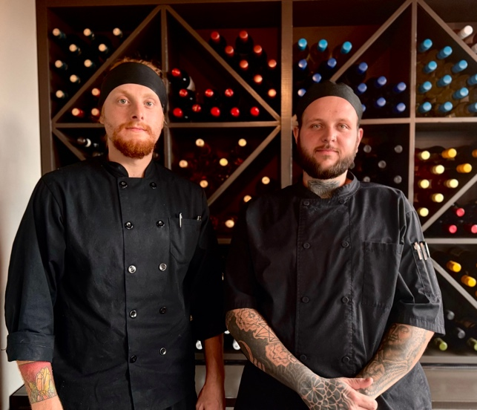
A or B) Chef de Cuisine Ian Mitchell (left) and Executive Chef Zach Anderson (right) have curated a menu of regional and worldwide flavors at Courses Restaurant.
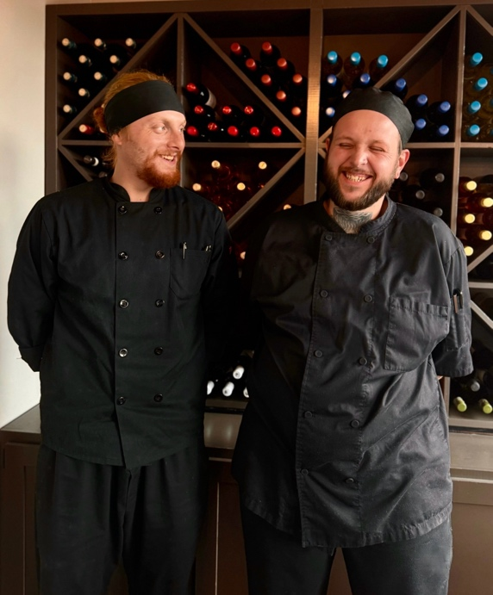

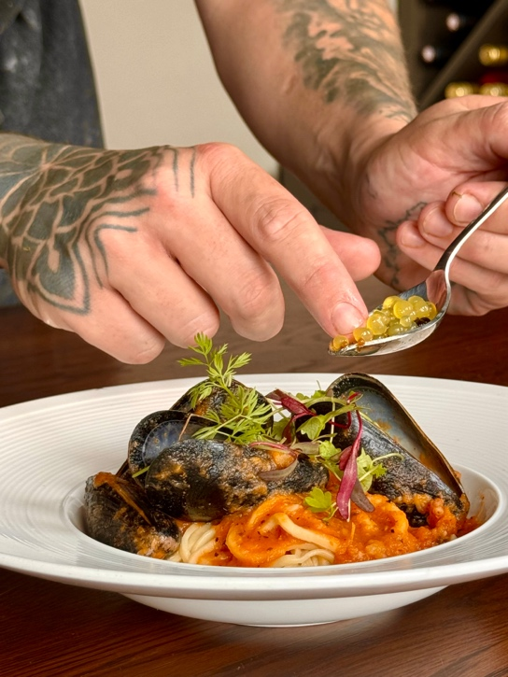
C) Executive Chef Zach Anderson garnishes mussels with fresh microgreens and lemon and balsamic spheres.

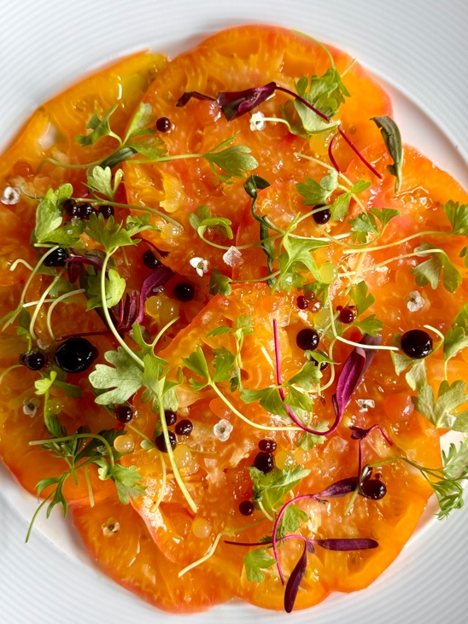
D) The tomato carpaccio features fresh, all-Appalachian Mr. Stripey tomatoes and smoked Maldon salt.
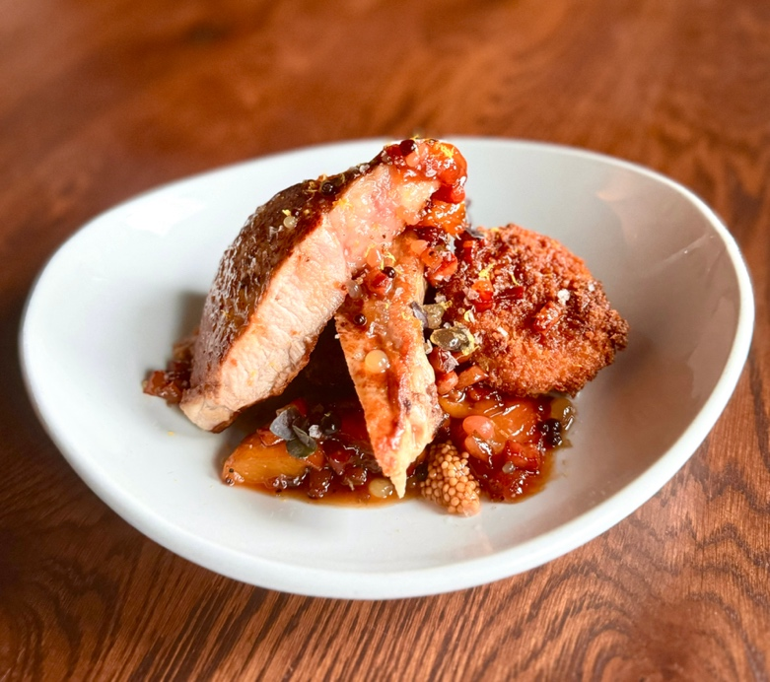
E) The signature umami pork chop is served over locally ground polenta cakes with a rosemary/local peach/wine sauce.

